Practical No.2

Using the AS_PATH Attribute –

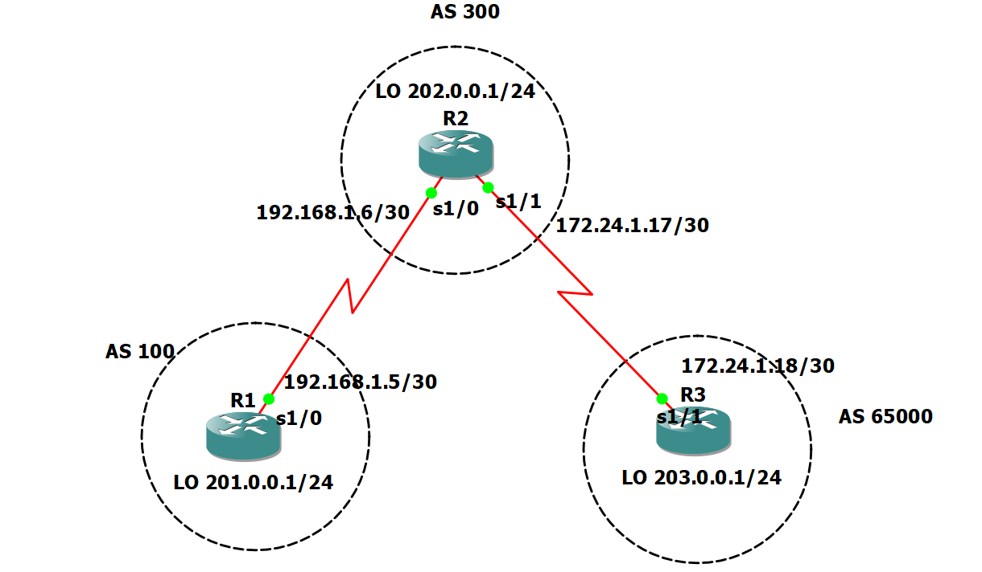

In this lab, the student will use BGP commands to prevent private AS numbers from being advertised

to the outside world. The student will also use the AS_PATH attribute to filter BGP routes based on

their source AS numbers.

**Scenario**

The International Travel Agency’s Internet service provider ISP2 has been assigned an AS number

of 300. This provider uses BGP to exchange routing information with several customer networks.

Each customer network is assigned an AS number from the private range, such as AS 65000.

Configure ISP2 to remove the private AS numbers within the AS_Path information from the CusRtr.

In addition, Provider ISP2 would like to prevent its customer networks from receiving route

information from International Travel Agency’s AS 100. Use the AS_PATH attribute to implement this policy.

IP ADDRESS CONFIGURATION –

R1 Commands –

R1#Conf Term

R1(config)#INT S1/0

R1(config-if)#NO IP ADDRESS

R1(config-if)#IP ADDRESS 192.168.1.5 255.255.255.252

R1(config-if)#NO SHUT

R1(config-if)#EXIT

R1(config)#INT LO0

R1(config-if)#IP ADDRESS 201.0.0.1 255.255.255.0

R1(config-if)#NO SHUT

R1(config-if)#EXIT

R2 COMMANDS –

R2#CONF TERM

R2(config)#INT S1/0

R2(config-if)#IP ADDRESS 192.168.1.6 255.255.255.252

R2(config-if)#NO SHUT

R2(config-if)#EXIT

R2(config)#INT S1/1

R2(config-if)#IP ADDRESS 172.24.1.17 255.255.255.252

R2(config-if)#NO SHUT

R2(config-if)#EXIT

R2(config)#INT LO0

R2(config-if)#IP ADDRESS 202.0.0.1 255.255.255.0

R2(config-if)#NO SHUT

R2(config-if)#EXIT

R3 COMMANDS –

R3#CONF TERM

R3(config)#INT S1/1

R3(config-if)#IP ADDRESS 172.24.1.18 255.255.255.252

R3(config-if)#NO SHUT

R3(config-if)#EXIT

R3(config)#

R3(config)#INT LO0

R3(config-if)#IP ADDRESS 203.0.0.1 255.255.255.0

R3(config-if)#NO SHUT

R3(config-if)#EXIT

Build and configure the network according to the diagram, but do not configure a routing protocol.

Use **ping** to test connectivity between the directly connected routers.

Configure BGP for normal operation. Enter the appropriate BGP commands on each router so that

they will identify their BGP neighbors and advertise their Ethernet networks –

R1 (config)#**router bgp 100**

R1 (config-router)#**no synchronization**

R1 (config-router)#**neighbor 192.168.1.6 remote-as 300**

R1 (config-router)#**network 201.0.0.0**

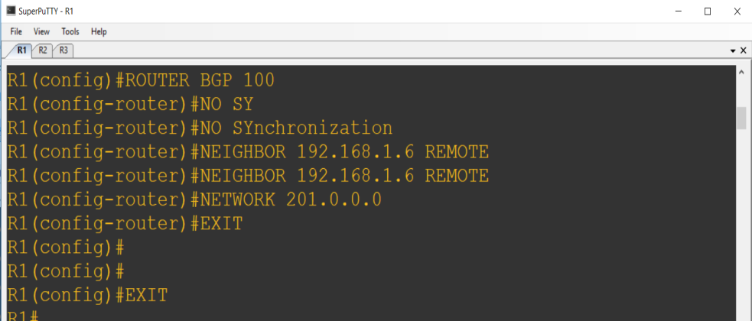

R2 (config)#**router bgp 300**

R2(config-router)#**no synchronization**

R2 (config-router)#**neighbor 192.168.1.5 remote-as 100**

R2 (config-router)#**neighbor 172.24.1.18 remote-as 65000**

R2 (config-router)#**network 202.0.0.0**

R3 (config)#**router bgp 65000**

R3 (config-router)#**no synchronization**

R3 (config-router)#**neighbor 172.24.1.17 remote-as 300**

R3 (config-router)#**network 203.0.0.0**

Verify that these routers have established the appropriate neighbor relationships by issuing the

**Show ip bgp neighbors** command at each router.

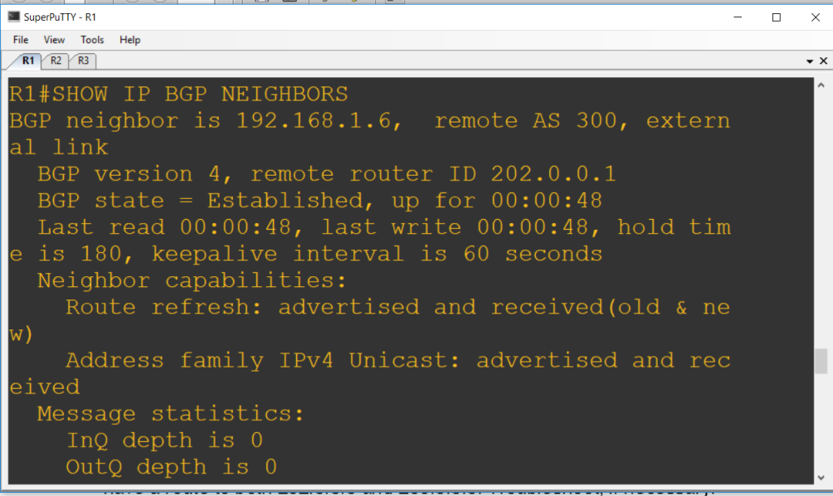

Check the routing table from R1 by using the **show ip route** command. R1 should have a route to both 202.0.0.0 and 203.0.0.0.

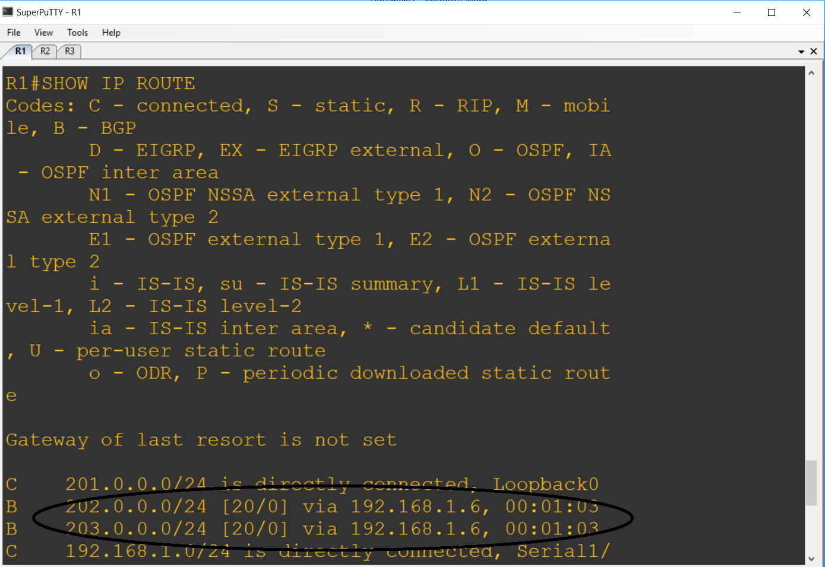

Check the BGP table from R1 by using the **show ip bgp** command. Note the AS path for the 203.0.0.0 network. The AS 65000 should be listed in the path to 203.0.0.0.

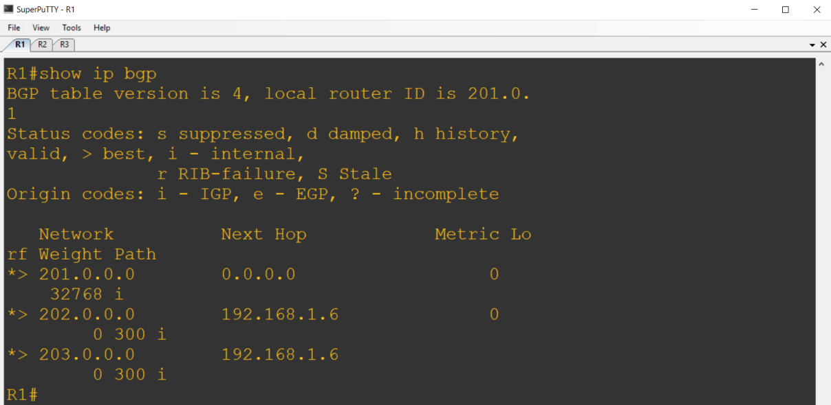

Configure R2 to strip the private AS numbers from BGP routes exchanged with R1. Use the

following commands:

R2(config)#**router bgp 300**

R2(config-router)#**neighbor 192.168.1.5 remove-private-as**

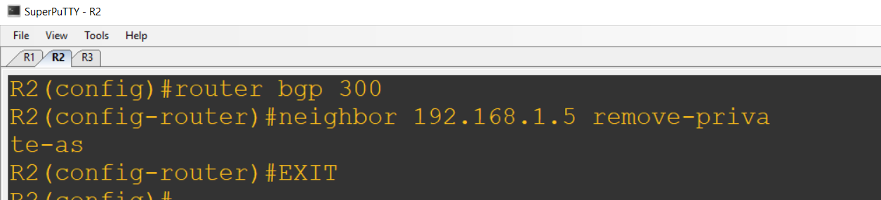

After issuing these commands, use the **clear ip bgp \*** command on R1 to re-establish

the BGP relationships between the three routers.

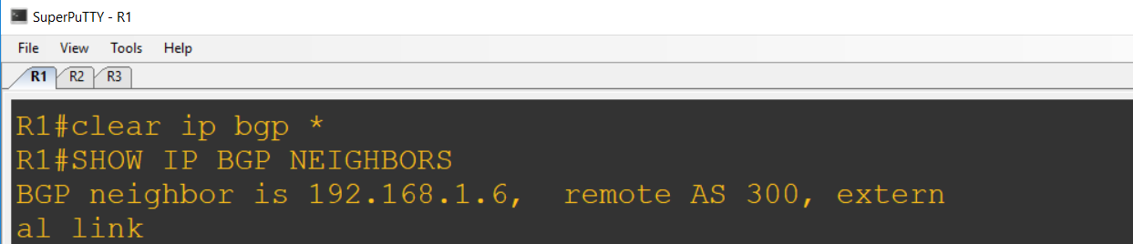

Wait several seconds, and then return to R1 to check its routing table.

R1 should be able to ping 203.0.0.0.

Now check the BGP table on R1. The AS_PATH to the 203.0.0.0 network should be AS 300.

As a final configuration, use the AS_PATH attribute to filter routes based on their origin. In a complex environment, this attribute can be used to enforce routing policy. In this case, the provider router R2, must be configured so that it does not propagate routes that originate from AS 100 to the

customer router, R3.

First, configure a special kind of access list to match BGP routes with an AS_PATH attribute that

both begins and ends with the number 100. Enter the following commands on R2:

R2(config)#**ip as-path access-list 1 deny ^100$**

R2(config)#**ip as-path access-list 1 permit .\***

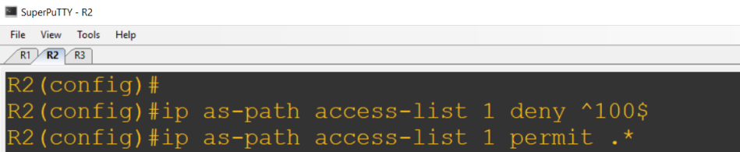

Now that the access list has been configured, apply it as follows:

R2(config)#**router bgp 300**

R2(config-router)#**neighbor 172.24.1.18 filter-list 1 out**

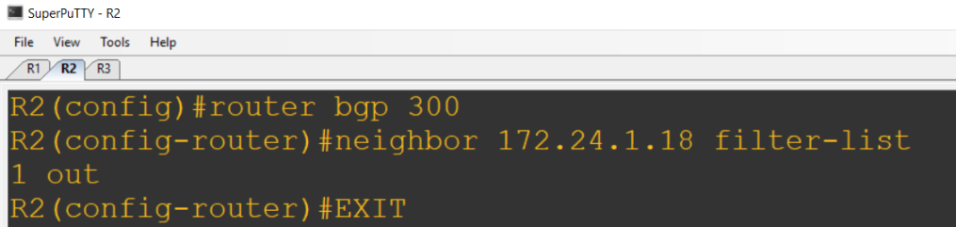

The **out** keyword specifies that the list should be applied to routing information sent to this neighbor.

Use the **clear ip bgp \*** command to reset the routing information. Wait several seconds, and

then check the routing table for R2. The route to 201.0.0.0 should be in the routing table.

Check the routing table for R3. It should not have a route to 201.0.0.0 in its routing table.

Return to R2 and verify that the filter is working as intended. Issue the command **show ip bgp**

**regexp ^100$**.

The output of this command shows all matches for the regular expressions that were used in the

access list. The path to 201.0.0.0 matches the access list and is filtered out of updates to R3.

